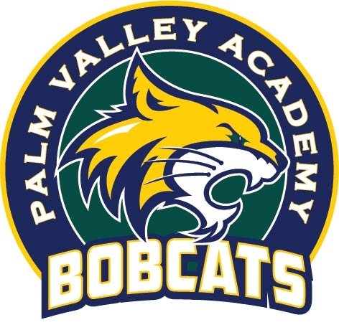
PALM VALLEY ACADEMY PTO
700 BOBCAT LANE, PONTE VEDRA, FL 32081
Dear Palm Valley Academy Families,

On behalf of the PVA PTO, we would like to welcome all of our new families and welcome back all of our returning families. After such an auspicious end to the 2019-2020 school year and the subsequent decisions each family has had to make regarding the return to school, we are hopeful that the 2020-2021 school year sees a slow return to normalcy.

In the meantime, the PTO has been hard at work ensuring we provide the support our children, teachers, and staff require to remain as safe, comfortable and happy as possible. This includes the provision of additional masks, the addition of branded masks to our school apparel line, $7500 worth of hand sanitizer and Clorox wipes for our classrooms, and expanded support for technology subscriptions.

In parallel to these activities, we are doing what we can to continue as many of our normal back to school activities as possible. This includes the creation and distribution of back to school folders and supplies, support and resource grants for our teachers, and, of course, fundraising for the school.

With your help last year, the PTO was able to raise enough money to expand its technology subscriptions, provide additional trainings for teachers, build a new outdoor seating area and a new outdoor activity pad, buy additional devices for all classrooms, and set aside funds for additional outdoor water fountains. In addition to the financial contribution, our community has logged hundreds of volunteer hours. This community has shown, yet again, how incredibly supportive it is and we can’t thank you enough for all you do to make Palm Valley Academy an incredible school!

This year may look a little bit different but the school would still love your support. You can still support the children and teachers of Palm Valley Academy in multiple ways:

- Join the PTO! You can sign up at pvapto.org/Membership. This is a one-time financial commitment and it comes with benefits! No time commitment is required.
- Become a Volunteer! Sign up to become a volunteer at pvapto.org/Volunteer
- Purchase Spirit Wear Online! For the first time ever, our entire line of spirit wear will be available for online purchase. You can find your Bobcat gear at pvapto.org/SpiritWear
Please follow us on facebook @palmvalleyacademypto and visit our website pvapto.org for updates – we will be making every effort to communicate more digitally throughout the year!

Thank you, as always, for your support. We are looking forward to a wonderful school year!

Go Bobcats!

Cole Naldzin & Kay Crouch
Palm Valley Academy Co-Presidents
president@pvapto.org

